Project document: Basic Animation 02.04.

Alberto Pacheco

Elitsa Raycheva

Joao Camarao

Mathilde Frachon

Nikoletta Es

Lana Sladović

Some Like It Hot

Idea and the concept of the teaser

The idea of our teaser is based on the plot of the movie - two guys who disguise themselves as girls and join a traveling girls band in order to escape from the mafia. And because it should be interactive the user should prevent the two boys -'Daphne' and 'Josephine' - from revealing their identity. The action takes place during a cabaret show when numerous incidents with our main characters happen.Every time something like this happens it becomes highlighted and the user should click on it before the time's up.We decided to leave the ending open to the imagination just like in the real movie so the user can decide for himself how this unusual love story ends.  
When creating our teaser our main goal was to convey the message of the movie that "Nobody's perfect!" in a humorous and interesting way.

Design

About our design we aimed to keep late 1950's style for our characters and background.

We used collage technique to create the characters.

Our color scheme is consisted of black, white and yellow.The font used for the title is "Great vibes".

Sketches and final graphics

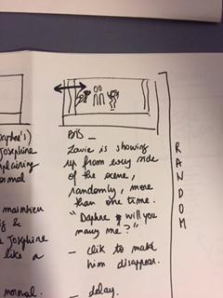 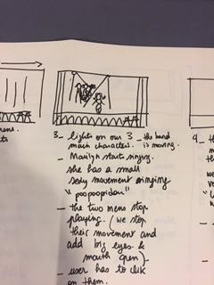 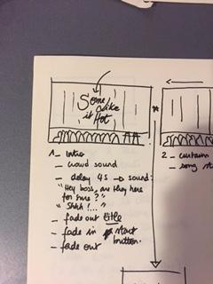

**Sketches for the moodboard**

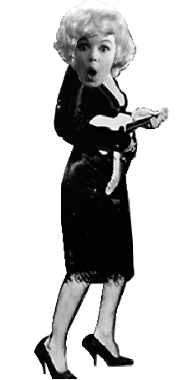 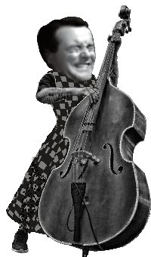 

Sequence diagram

Listing of the individual contributions to the project

Design: Joao Camarao

Mathilde Frachon

Elitsa Raycheva

Nikoleta Smolkova

Lana Sladovic

Alberto Pacheco

Coding: Alberto Pacheco

Mathilde Frachon

Sound: Lana Sladovic

Final remarks

Trough out the project we had different ideas which we managed to combine, using each of our skills.